**University Institute of Information Technology**

**MPL-Lab 01**

|  |  |  |  |
| --- | --- | --- | --- |
| **Course Code:** | CS-432 | **Subject:** | MPL |
| **Lab Manuals** |  | **Class/Lab Instructor:** |  |

**Learning Objective:**

1. What is Modern Programming Language?
2. Introduction to JAVA language
3. Why we need to learn JAVA?
4. How to install JAVA language compiler & JDK Setup on laptop?
5. How to create JAVA projects?
6. Exercises.

**Introduction to Java:**

Java is a high-level programming language originally developed by Sun Microsystems and released in 1995. Java runs on a variety of platforms, such as Windows, Mac OS, and the various versions of UNIX.

Object Oriented − In Java, everything is an Object. Java can be easily extended since it is based on the Object model.

Platform Independent − Unlike many other programming languages including C and C++, when Java is compiled, it is not compiled into platform specific machine, rather into platform independent byte code. This byte code is distributed over the web and interpreted by the Virtual Machine (JVM) on whichever platform it is being run on.

Simple − Java is designed to be easy to learn. If you understand the basic concept of OOP Java, it would be easy to master.

**Installation Link:**

<https://drive.google.com/file/d/1QwcUio57hJoFiIRaWdOLaPbjpzKifgtd/view?usp=sharing>

<https://www.filehorse.com/download-java-development-kit-64/35914/download/>

Note: The second link is JDK 10

**Creating a java Project:**

Open NetBeans:

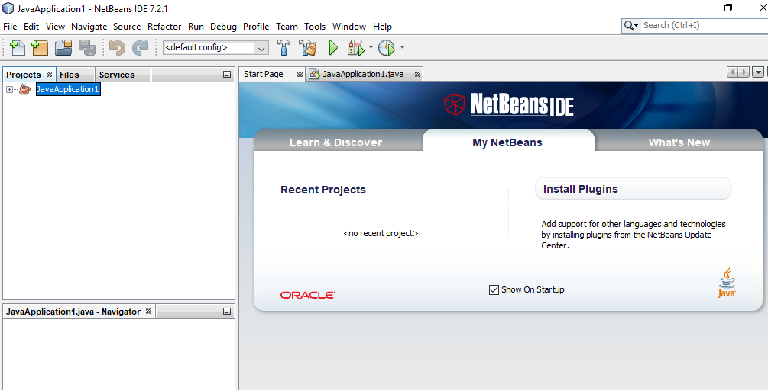

In the NetBeans IDE, choose **File** | **New Project...**.

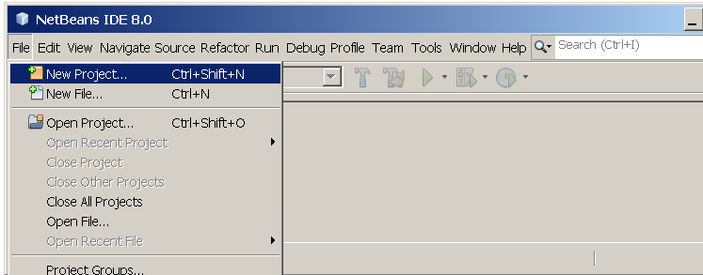

In the **New Project** wizard, expand the **Java** category and select **Java Application** as shown in the following figure:

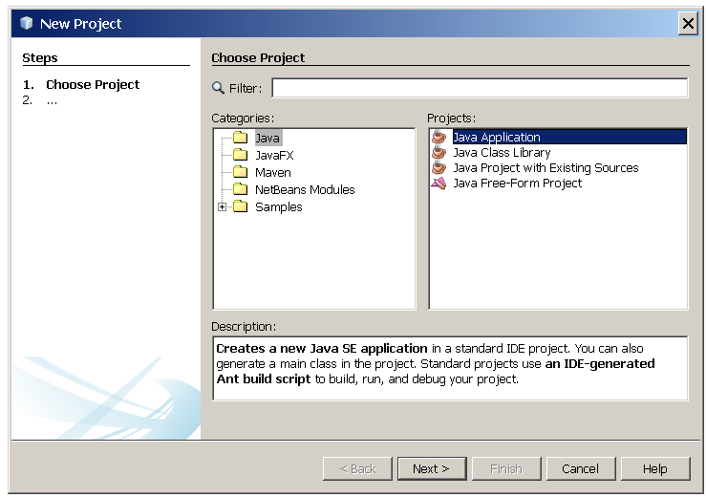

In the **Name and Location** page of the wizard, do the following (as shown in the figure below):

* In the **Project Name** field, type Hello World App.
* In the **Create Main Class** field, type helloworldapp.HelloWorldApp.

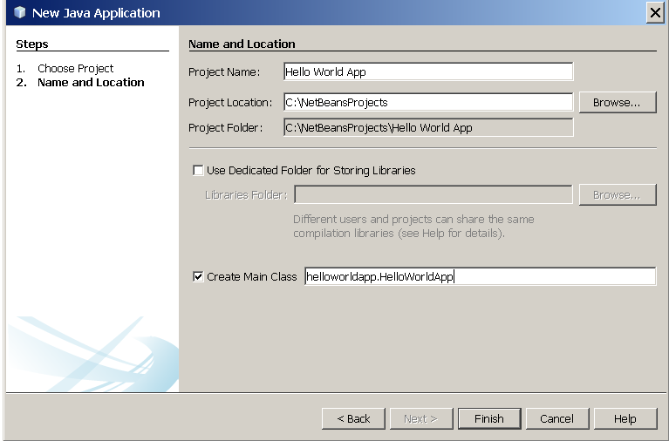

Click Finish.

The project is created and opened in the IDE. You should see the following components:

* The **Projects** window, which contains a tree view of the components of the project, including source files, libraries that your code depends on, and so on.
* The **Source Editor** window with a file called HelloWorldApp.java open.
* The **Navigator** window, which you can use to quickly navigate between elements within the selected class.

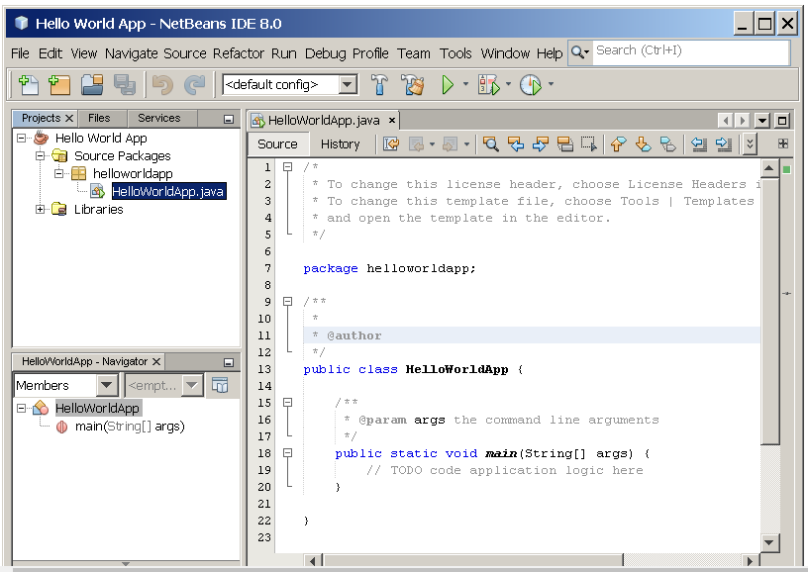

**Example Code:**

|  |
| --- |
| public class MyFirstJavaProgram {  /* This is my first java program.  * This will print 'Hello World' as the output  */  public static void main(String []args) {  System.out.println("Hello World"); // prints Hello World  }  } |

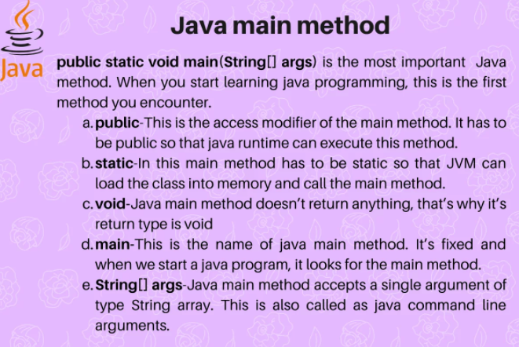

**Program # 1** Write Java Code to Print WelCome Message on Screen

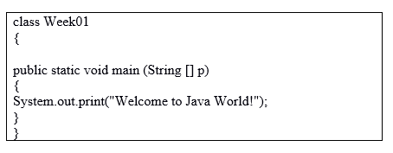

**Program # 2** Write Java Code to declare three numbers

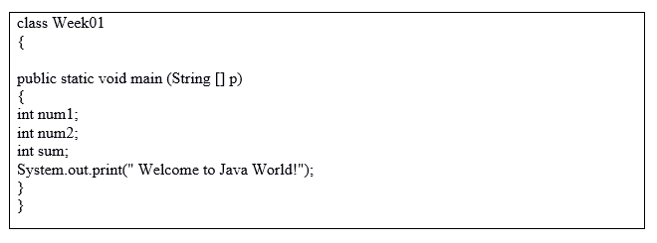

**Program # 3** Write Java Code to Print the sum of two integers

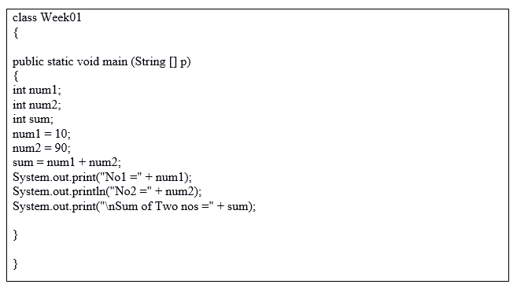

**Program # 4** Write Java Code to Print sum of double numbers(floating point)

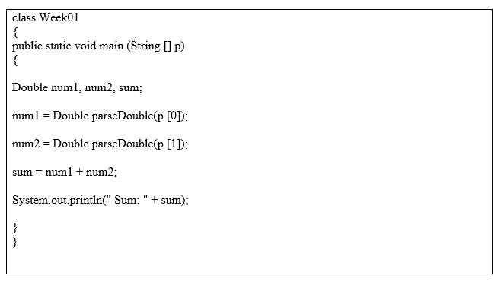

**Program 5 #** Write Java Code to Print the result of the following operations.

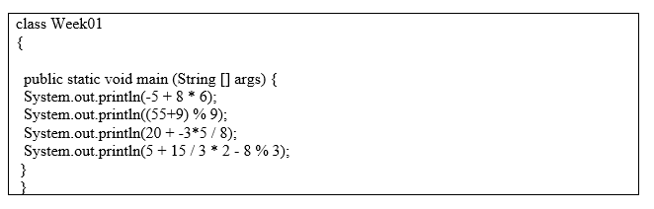

**Program 6 #** Write Java Code to Print that takes a number as input and prints its multiplication table upto 10.

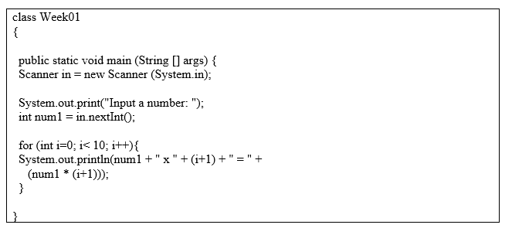

**Program 7 #** Write Java Code to Print the ascii value of a given character.

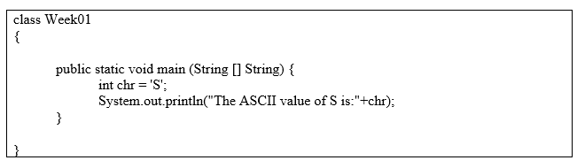

**Lab Tasks:**

* Write a Java program that takes two numbers as input and display the product of two numbers.
* Write a Java program that takes your ARID number and name as an input and then show on screen with separate two line.
* Write a Java program that takes three numbers as input to calculate and print the average of the numbers